TECHNICAL PROJECT DIARY

VOCABULARY APP BASED ON ANDROID

**By:**

1. **DEBASIS KAR**

**(Roll No:** RA1901A49**; Reg No:** 10908166**)**

1. **ROOPALI SAHOO**

**(Roll No:** RA1901A50**; Reg No:** 10901410**)**

**Section: A1901 (LHST-CSE)**

**Course Code: GEN821**

**Mentor(s):**

**Dr. Abhishek Vaid**

**Dr. Sankar S. Srivatsa**



|  |  |  |  |  |
| --- | --- | --- | --- | --- |
| Date | Week No | Subject/Progress | Page No | Signature |
| 14TH JAN, 2011 | 1 | Overview of project, overview of Android SDK by running “Hello Android” code. | 3 |  |
| 21ST JAN, 2011 | 2 | Overview of Android programs to do some sort of animation and listing on screen. | 3 |  |
| 28TH JAN, 2011 | 3 | Overview of XML language and Java | 4 |  |
| 4TH FEB, 2011 | 4 | Overview of various GRE and vocabulary books and related softwares. | 5 |  |
| 11TH FEB, 2011 | 5 | Database Data Collection In MS-Excel | 5 |  |
| 18TH FEB, 2011 | 6 | Database Data Collection In MS-Excel and finally converting into database with MySQL. | 5 |  |
| 25TH FEB, 2011 | 7 | Data Modeling, ER-Diagram  & Database Analysis | 6 |  |
| 4TH MAR, 2011 | 8 | ---NO PROGRESS (MTE)--- | 7 | --- |
| 11TH MAR, 2011 | 9 | ---NO PROGRESS (MTE & Vacations)--- | 7 | --- |
| 21ST MAR, 2011 | 10 | Design Of SRS and Use Cases Of Software | 7 |  |
| 28TH MAR, 2011 | 11 | Design Of SRS and Use Cases Of Software | 8 |  |
| 4TH APR, 2011 | 12 | Basic Coding To Display List Of Words and giving some customization. |  |  |
| 11TH APR, 2011 | 13 | Basic Coding To Display List Of Words and giving animated effects. |  |  |
| 18TH APR, 2011 | 14 | Basic Coding To Display List Of Words and customizable background and menu systems. |  |  |
| 25TH APR, 2011 | 15 | Basic Coding To Display List Of Words and feedback intents and options. |  |  |
| 1ST MAY, 2011 | 16 | Basic Coding To Display List Of Words and showing them albhateically. |  |  |

**WEEK-1**

PROJECT OVERVIEW:-

To develop a vocabulary mobile application aiming Android phones which will be helpful for many GRE aspirants to excel in GRE and also to enhance and strengthen their vocabulary of English.

INSTALLATION AND TESTING :-

We installed the following components of required SDK to develop a mobile application for Android OS- loaded cells.

These are:

* Android SDK (rev 8.0)
* JRE 6.0 (23rd update)
* JDK
* Eclipse (Helios )- classic
* ADT Plug-In

Platform decided to develop upon- Windows 7/Vista.

Checked and downloaded all needed APIs and successfully tested “HELLO ANDROID!!!” program.

**WEEK-2**

WORK OVERVIEW:-

We overviewed of Android programs to do some sort of animation and listing on screen.

Done radio button, check box selection etc as shown in the window.

**WEEK-3**

PROJECT OVERVIEW:-

Overview of XML language and Java

TESTING :-

XML:-

* **Extensible Markup Language** (**XML**) is a set of rules for encoding documents in [machine-readable](http://en.wikipedia.org/wiki/Machine-readable) form. It is defined in the XML 1.0 Specification produced by the [W3C](http://en.wikipedia.org/wiki/W3C), and several other related specifications, all [gratis](http://en.wikipedia.org/wiki/Gratis) [open standards](http://en.wikipedia.org/wiki/Open_standard).
* XML's design goals emphasize simplicity, generality, and usability over the [Internet](http://en.wikipedia.org/wiki/Internet). It is a textual data format with strong support via [Unicode](http://en.wikipedia.org/wiki/Unicode) for the languages of the world. Although the design of XML focuses on documents, it is widely used for the representation of arbitrary data structures, for example in [web services](http://en.wikipedia.org/wiki/Web_service).
* Mostly in Android we use XML language for layout designs.

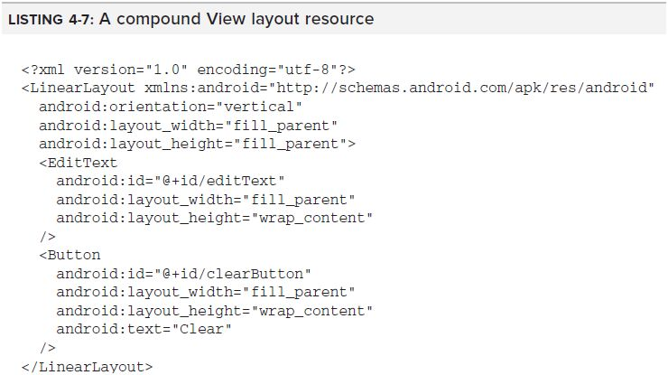A Sample XML Snippet Used In Android:

**WEEK-4**

PROJECT OVERVIEW:-

Overview of various GRE and vocabulary books and related softwares.

TESTING :-

We searched many GRE books and studied it and selected two books.

* BARRON’S GRE by Sharon Weiner-Green and Ira K.Wolf
* 1000 Most Important Words by Norman Schur

**WEEK-5 &6**

PROJECT OVERVIEW:-

Database Data Collection In MS-Excel and finally converting into database with MySQL.

TESTING :-

We collected data from A-Z and made an MS-Excel file. We used ODBC connector software to make database in MySQL and MS-Access.

Both versions are of MS-Office 2007 package.

We studied some basic concept of database designing and the basic commands of MySQL.

**Ex:**

* SELECT
* UPDATE
* DELETE
* INSERT
* MERGE etc.

Sample Code On Book Database

SELECT Book.title,

count(*) AS Authors

FROM Book JOIN Book_author

ON Book.isbn = Book_author.isbn

GROUP BY Book.title;

Used MySQL Version: MySQL 5.5.10

**WEEK-7**

PROJECT OVERVIEW:-

Modeled the data according to the functional requirements and then finalized a final ER-Diagram.

TESTING :-

* Data modeling in software engineering is the process of creating a data model by applying formal data model descriptions using data modeling techniques.
* In software engineering, an entity-relationship model (ERM) is an abstract and conceptual representation of data.
* Entity-relationship modeling is a database modeling method, used to produce a type of conceptual schema or semantic data model of a system, often a relational database, and its requirements in a top-down fashion. Diagrams created by this process are called entity-relationship diagrams, ER diagrams, or ERDs.

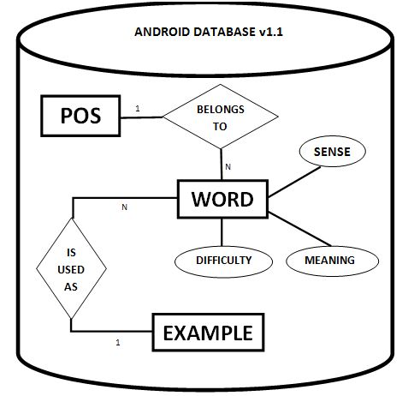The database was saved having following fields: WORDS, PARTS OF SPEECH, MEANING, DIFFICULTY, SENSE & EXAMPLE.

**WEEK-8 & 9**

No progress due to MTE and vacations.

**WEEK-10 & 11**

PROJECT OVERVIEW:-

Design of SRS & Use cases of software.

TESTING :-

**SRS**

* A Software Requirements Specification (SRS) - a requirements specification for a software system - is a complete description of the behavior of a system to be developed. It includes a set of use cases that describe all the interactions the users will have with the software.
* Use cases are also known as functional requirements. In addition to use cases, the SRS also contains non-functional (or supplementary) requirements. Non-functional requirements are requirements which impose constraints on the design or implementation (such as performance engineering requirements, quality standards, or design constraints).

**USE CASE**

* The specific way use cases are used within the development process will depend on which development methodology is being used.
* In certain development methodologies, a brief [use case survey](http://en.wikipedia.org/wiki/Use_case_survey) is all that is required. In other development methodologies, use cases evolve in complexity and change in character as the development process proceeds.
* Use cases can be a valuable source of usage information and usage testing ideas. In some methodologies, they may begin as brief business use cases, evolve into more detailed system use cases, and then eventually develop into highly detailed and exhaustive test cases.

A proper SRS is formulated before the final coding to be started.

**WEEK-12,13,14,15 & 16**

Basic Coding to Display List of Words and giving various customizations as prescribed in SRS.

**\*\*\*\*\*\*\*\*\*\*\*\*\*\*\*\*\*\*\*\*\*\*\*\*\*\*\*\*\*\*\*\*\*\*\*\*\*\*\*\*\*\*\*\*\*\*\*\*\*\*\*\*\*\*\*\*\*\*\*\*\*\*\*\*\*\*\***

**Debasis Kar**

**RA1901-A49**

**Roopali Sahoo**

**RA1901-A50**